Curriculum Policy

Safeguarding Statement
West Heath Primary will continuously strive to ensure that everyone in our school is treated with respect and dignity. Each person in our school will be given fair and equal opportunity to develop their full potential with positive regard to gender, ethnicity, cultural and religious background, sexuality or disability. West Heath Primary School is committed to safeguarding and promoting the welfare of children and young people and expects all staff to share this commitment.

Owner | Headteacher
Date of review | March 2024
Date of next review | March 2025

Curriculum Policy

Audience
This policy has been written so that all staff follow our expectations for our interpretation of the National Curriculum.

Curriculum Intent
At West Heath there is a collective understanding that children learn best when they are inspired by their learning; when they are active and when they are physically and emotionally healthy. We have worked hard to develop an inspiring curriculum that equips our children with the skills and knowledge necessary to live as responsible citizens in modern Britain. We truly want our pupils to believe that anything is possible!

Our curriculum is mapped to include coverage of the National Curriculum and provides a range of experiences for our children. At West Heath we champion every child to, ‘Be a Star Shine Bright!’

Curriculum Implementation
At West Heath we have three curriculum drivers. These are the things that underpin our curriculum; the things we believe give our school its unique identity.
Our first curriculum driver is Physical Activity, which we passionately believe can play a crucial role in child development. We offer our children as many opportunities as possible to take part in an extensive range of sports, whilst also seeking out opportunities to include active elements in lessons across the entire curriculum.
Our second curriculum driver is Values Education, which also permeates everything we do. We believe that helping our pupils to develop strong values will give them the platform to go on and make a success of their future lives. As a school, we have seven values: collaboration, honesty, empathy, respect, resilience, determination and excellence. We teach children how to use and understand these values, so that they can grow into reflective individuals who make positive contributions to society and enjoy all the world has to offer.
Our final curriculum driver is Reading. As a school we have made a commitment to ensuring that every child will leave our school as a competent reader, regardless of their ability. This commitment to reading is evident in all aspects of school life.
These curriculum drivers are at the heart of our curriculum, along with the core subjects of English, Mathematics and Science. However, we also value our wider curriculum, and our curriculum covers all other National Curriculum subjects. We are committed to ensuring that our children are exposed to a wide and varied range of learning experiences. Our curriculum is designed so that specific knowledge and skills are scaffolded within a topic for every subject area each half term, balancing new learning with reinforcing previous key concepts too.
In order to ensure that progression and balance is maintained, the programmes of study have been developed into comprehensive curriculum maps, which clearly outline the skills and knowledge our children should gain. Teachers use these to generate medium term plans (MTPs) which clearly highlight the learning objectives, steps to success, key teaching and the tasks to be completed to ensure the children achieve the objective. Teachers deliver these MTPs as weekly lessons in each subject area where the specific needs of the learners are addressed.

Curriculum Impact
We aim for all of our children to leave West Heath:
- Equipped with the skills and knowledge needed to be lifelong learners
- Believing that with hard work and determination, anything is possible
- To be respected citizens ready to make valuable contributions to social capital
- To understand the importance of leading a healthy lifestyle through physical activity and emotional wellbeing
- To read with fluency

Legislation and Guidance
This policy reflects the requirements of the National Curriculum programmes of study, which all maintained schools in England must teach.
It also reflects requirements for inclusion and equality as set out in the Special Educational Needs and Disability Code of Practice 2014 and Equality Act 2010, and refers to curriculum-related expectations of governing boards set out in the Department for Education’s Governance Handbook.
In addition, this policy acknowledges the requirements for promoting the learning and development of children set out in the Early Years Foundation Stage (EYFS) statutory framework.

National Curriculum
The curriculum provided for our pupils will cover the following National Curriculum subjects:
- English
- Maths
- Science
- Art and Design
- Computing
- Geography
- History
- Music
- Design Technology
- PE
- RE (for which we follow the Birmingham, agreed syllabus)
- Languages (Spanish) (in Key Stage 2)
- PSHE
We recognise and promote the key importance of the core subjects and developing the pupils’ expertise in reading, writing and maths. We aim to activate the pupils’ learning in these subjects in innovative, creative and exciting ways. We firmly believe that this should be balanced within both the whole National Curriculum and the wider school curriculum.
The curriculum should not fully prioritise Core subject learning at the expense of a broad and balanced curriculum or pupils’ holistic development, but each should support and enhance the other aspects.
Spiritual, Moral, Social and Cultural
There are numerous opportunities for supporting the pupils’ SMSC development through all areas of the curriculum. It is promoted through RE sessions, Circle Times, discussions about class and school rules, collective worship, values education, and through positive sharing of the variety of languages and cultural identities of our pupils, their families and the wider world.
Roles and Responsibilities
Headteacher
The headteacher is responsible for ensuring that this policy is adhered to, and that:
- All required elements of the curriculum, and those subjects which the school chooses to offer, have aims and objectives which reflect the aims of the school and indicate how the needs of individual pupils will be met
- The amount of time provided for teaching the required elements of the curriculum is adequate and is reviewed by the governing board
- Where appropriate, the individual needs of some pupils are met by permanent or temporary disapplication from all or part of the National Curriculum
- They manage requests to withdraw children from curriculum subjects, where appropriate
- The school’s procedures for assessment meet all legal requirements
- The governing board is fully involved in decision-making processes that relate to the breadth and balance of the curriculum
- The governing board is advised on whole-school targets in order to make informed decisions
- Proper provision is in place for pupils with different abilities and needs, including children with SEND
Subject Leaders
Subject Leaders ensure that all the aspects of the National Curriculum content are identified within subject curriculum maps. These are then transferred into MTPs either by the subject lead themselves or by class teachers, overseen and monitored by the subject coordinator.
In our school we use the head, hands and heart approach to plan, deliver and assess the objectives from the National Curriculum which will be covered and assessed in each year group. Subject Leaders monitor teaching and learning to ensure that pupils’ learning becomes increasingly more challenging as they move through the year groups, and to maintain an overview of standards within their subject.
Subject Leaders also produce annual action plans for their subjects, monitor and update the curriculum map and MTPs as required, analyse the standards within their subject, provide or signpost staff towards training and resources and engage in developmental work / research projects with external colleagues. They provide written feedback to governors, the Headteacher and staff to celebrate strengths and identify aspects for improvement.
Class Teachers
Class Teachers have the final responsibility to deliver class specific lessons in each subject, suited to the needs of their pupils. They also have responsibility for the standards their pupils achieve, the progress they make and the evidence of this learning. Teachers set high expectations for all pupils. They deploy appropriate assessment for learning, resources and differentiation in order to support and challenge all groups, including:
- More able pupils
- Pupils with low prior attainment
- Pupils from disadvantaged backgrounds
- Pupils with SEN
- Pupils with English as an additional language (EAL)
Teachers will plan lessons so that pupils with SEN and/or disabilities can study every National Curriculum subject and ensure that there are no barriers to every pupil achieving the desired lesson outcomes.
Teachers will also take account of the needs of pupils whose first language is not English. Lessons will be planned so that teaching opportunities help pupils to develop their English, and to support pupils to take part in all subjects.
They are responsible for ensuring the curriculum is differentiated to meet the needs of all children within their class. Teachers update the curriculum tracker on Fisher Family Trust Aspire on a termly basis.
The Governing Body
The governing board will monitor the effectiveness of this policy and hold the Headteacher to account for its implementation.
The governing board will also ensure that:
- A robust framework is in place for setting curriculum priorities and aspirational targets
- Enough teaching time is provided for pupils to cover the National Curriculum and other statutory requirements
- Proper provision is made for pupils with different abilities and needs, including children with special educational needs (SEN)
- The school implements the relevant statutory assessment arrangements
- It participates actively in decision-making about the breadth and balance of the curriculum
- It fulfils its role in processes to disapply pupils from all or part of the National Curriculum, where appropriate, and in any subsequent appeals

Procedure for English and Maths

Weekly planning for both maths and English is based upon the school’s curriculum map and is saved into the year group folder on the Friday before it is taught. Planning is monitored by subject leaders. More specific information in relation to this can be found in the English and Maths policy.

Procedure for Non-core Subjects and Science
Detailed curriculum maps for every subject are provided to staff. These show what knowledge and skills need to be taught and mastered each half term in all subjects. Teachers or subject leaders use this curriculum map to produce their medium-term plans. These maps are also available on the school website.
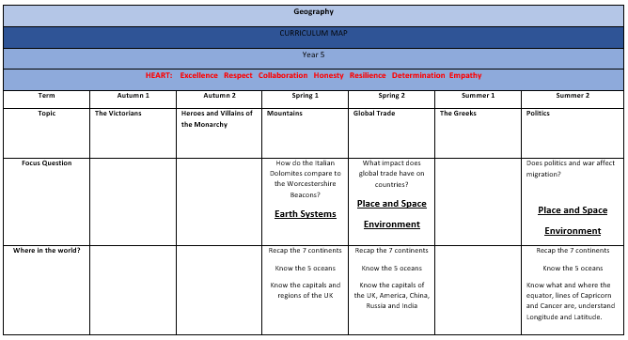
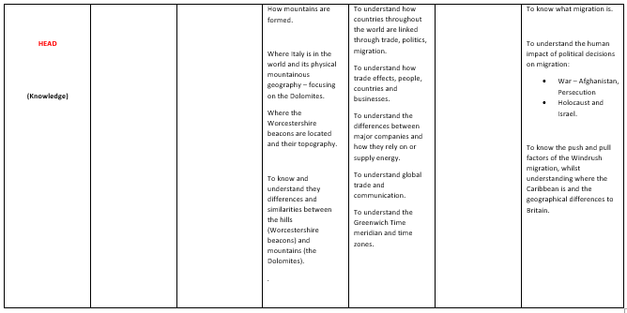
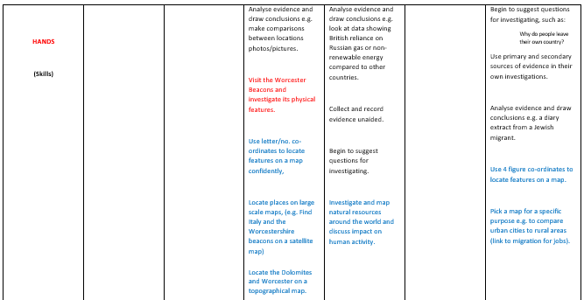
Medium Term Planning
Teachers or subject leaders use the curriculum maps to write their medium-term planning. Planning for each half term must be completed and saved into the relevant year group folders by the first Friday of each half term. All medium-term planning must be completed on the schools’ agreed format. This planning is then monitored by either the subject lead, curriculum lead or Deputy Head, with any agreed amendments made immediately. MTPs should achieve all objectives from the curriculum map and cover all of the necessary knowledge and skills during the unit.

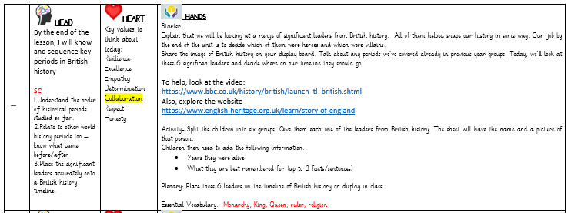

Early Years
Expectations for weekly planning
- Each week there must be a focus based upon a book from the recommended book list or following children’s interests. This may be extended if the children are enjoying the book and there is scope for further development. It is appropriate to change the book if the children’s interests take the learning in a different direction.
- The planning must outline the specific focus for the children in all key areas of learning. Planning should be shared with all members of the EYFS team.
- The planning must be mounted onto the planning whiteboard and annotated according to the children’s interests. There is no requirement to rewrite the sheet as it is a working document.
- The activities for the day must be shared with the children and the focus values must be shared every day.
- Children’s interests must drive the curriculum and therefore activities planned by the children must supersede adult led planning, should the need arise.
- Phonics planning should follow the expectations as laid out in the RWI scheme.

Expectations for weekly resourcing (in addition to continuous provision resources)
- Resources appropriate to the ‘story’ must be available each week in order that the children can access equipment to foster their imagination. Adults should pre-empt (as much as is reasonably practicable) the type of resource children might request.
- A collection of basic resources must be available for the children to easily access and should be replenished weekly (paper, string, scissors, boxes etc.)
- Pencils, in all areas, must be sharp.
- Books in all areas must be neatly and appropriately displayed and be appropriate to the age/stage of the children in EYFS.
- All resources are expected to be of a high standard and be readily available to children to access independently.
- All resources must be appropriately labelled with the number of items, colours, shapes, sizes appropriate the age and stage of the children. Resources MUST be changed regularly to meet the requirements of the ELG’s.
- All resources must have an identified space within the room which is understood by children.
- Any labels around the room must be accessible to children and should only be used if the children can read them or decode them.

Expectations for Medium Term Planning
- From the Spring term, EYFS begin weekly Music and Topic sessions. Medium-term planning must be completed and saved into the relevant folder by the first Friday of each half term.

Links with Other Policies
This policy links to the following policies and procedures:
- EYFS policy
- Assessment policy
- English Policy
- Maths Policy
- SEN policy and information report
- Equality information and objectives
- PSHE/RSE Policy
- All individual curriculum policies

Monitoring Arrangements
This policy will be reviewed every year by the senior leadership teams within school. At every review, the policy will be shared with the curriculum and standards committee of the governing body.

