Our Timetable
School opens for reading | 8.30 | 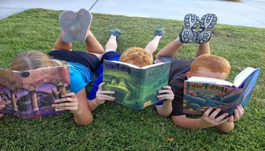
School starts  - Registration | 8.50 | 
Assembly | 9.00 | 
Lessons | 9.20 | 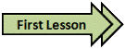
Lunchtime  - EYFS/KS1 lunchtime  - KS2 lunchtime | 11.30 -12.20  12.25- 1.15 | 
School ends | 3.00 | 
Total |  | 32.5 hours

