Mathematics Policy

Safeguarding Statement
West Heath Primary will continuously strive to ensure that everyone in our school is treated with respect and dignity. Each person in our school will be given fair and equal opportunity to develop their full potential with positive regard to gender, ethnicity, cultural and religious background, sexuality or disability. West Heath Primary School is committed to safeguarding and promoting the welfare of children and young people and expects all staff to share this commitment.

Mathematics Policy

Audience

This policy is designed to be used by teachers at West Heath Primary School to ensure the expectations in relation to the teaching of Mathematics are clear.

Equal opportunities

At West Heath Primary School, we will continuously strive to ensure that everyone in our school is treated with respect and dignity. Each person in our school will be given fair and equal opportunity to develop their full potential with positive regard to gender, ethnicity, cultural and religious background, sexuality or disability.

Aims

In line with the National Curriculum for Mathematics 2014, at West Heath we aim to ensure that pupils:

- Have fluent arithmetic skills appropriate to their age and stage which they can use to solve a variety of problems
- Have a sound understanding of calculation, number, shape, space and measure and handling and interpreting data
- Develop the ability to solve mathematical problems presented in a variety of contexts
- Have a positive attitude to Maths

Procedure

EYFS
Mathematics within the EYFS is developed through purposeful, play based experiences and will be represented throughout the indoor and outdoor provision. The learning will be based on pupil’s interests and the Development Matters / Early Years Outcomes. Mathematical understanding can be developed through stories, songs, games, imaginative play, child-initiated learning and structured teaching. The environment in EYFS has been set up to ensure the development of mathematical skills. Short Maths inputs are given daily to introduce new concepts and implemented into provision. Classroom equipment is labelled to show the quantity required and children are expected to ensure the right number of objects are returned at tidy up time.

KS1 and KS2
All children receive a daily Mathematics lesson, although mathematical skills run through many other areas of the curriculum. Each lesson has a clear learning outcome, which all children are expected to achieve; extension activities enable those children who grasp the objective rapidly to extend their learning by exploring it at greater depth. Teachers use the White Rose Maths scheme to produce their weekly planning and teaching resources. Whole class teaching is adopted and children work in mixed ability groups or children are placed into ability sets within their year groups. Every classroom has a range of practical apparatus to support children’s learning, with additional resources stored centrally in Mr Kendall’s classroom.
Medium Term Planning

Medium Term Planning is available on the White Rose Website. This is available to the teachers via a login that will be given at the beginning of the year. The planning gives teachers a yearly overview showing all topic areas to be covered in the year and the amount of time to be spent on each one.

Figure 1: Long term teaching overview
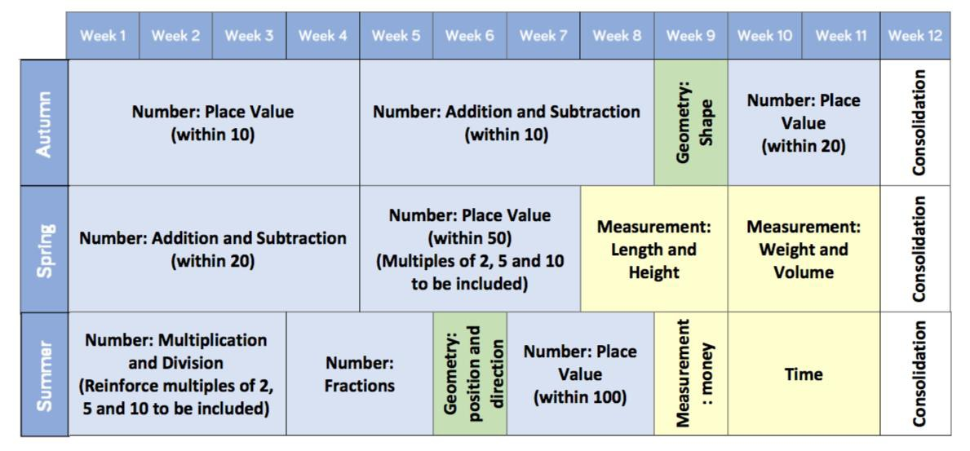

In addition to this long-term overview, unit overviews are also available which break down the learning into small steps, taken from the White Rose Hub. This identifies the teaching steps and the recommended amount of time to spend on each one. This is to ensure that teachers do not teach too many concepts at once as this can lead to cognitive overload.

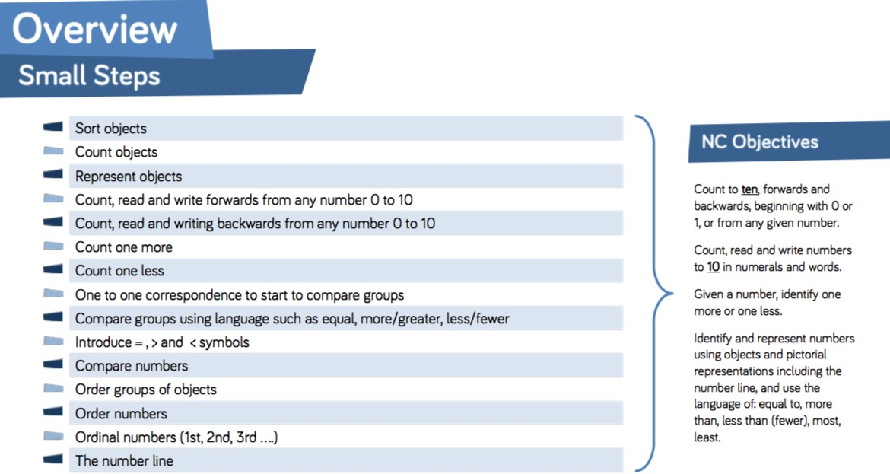
Figure 2: Small steps guidance

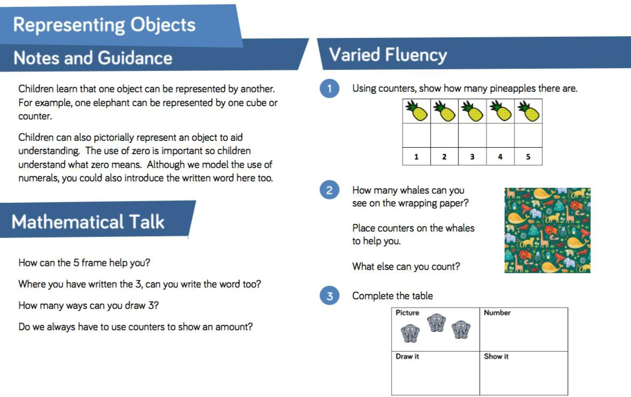
The scheme also gives clear teaching guidance and ideas for mathematical talk, varied fluency, reasoning and problem solving. Teacher are encouraged to use the ideas given in their lessons

Figure 3: Teaching guidance

Short Term Planning

Teachers are required to produce Short Term Planning based on the Medium-Term Planning. Weekly planning is to be produced on the schools agreed format and should use the head, heart and hands approach. This is then saved on the system at the beginning of the week and monitored by the Maths Leader. This should include dates, learning objectives, key vocabulary, key teaching principles, success criteria, focus values and differentiated learning opportunities for the pupils. PowerPoints to support teaching are provided on the teacher area of the website and these can be used to support learning.

Assessment
Formative assessment

Children should receive regular feedback during every lesson. This immediate verbal feedback should address misconceptions, as well as providing opportunities for pupils to deepen their understanding of a topic. Groupings in class should be fluid to ensure that children are constantly challenged.

The assessment of pupils is ongoing; class teachers must ensure that this informs future planning. Teachers mark work in Mathematics in line with the school’s Marking Policy.

Summative assessment

In October, March and June of each year, children will undertake PUMA standardised Mathematics tests. Following these tests, standardised scores will be calculated and analysed. Interventions will then be put into place for all children who are not making at least expected progress. Gaps in learning will be identified and interventions will be planned in order to ensure progress for all children. Effective use of pupil premium funding will be evaluated following each round of assessment. Provision for SEN pupils, LAC and those with EAL, will be evaluated termly.

Moderation

Teachers regularly moderate children’s work to ensure accurate teacher assessments. A file for this purpose which exemplifies work at the expected standard, below the expected standard and at greater depth within the expected standard, is kept by the Maths Coordinator. The folder is updated termly and books with evidence are kept at the end of the academic year.

Marking

In line with the school’s marking policy, all work produced in Maths must be marked. Teachers are also expected to give verbal feedback during lessons and model the correct methods to pupils.

Workbooks

Workbooks will be provided to accompany the units of work and will be given to the teacher before the unit of work begins. For most children these will be appropriate and should be used. However, if children cannot access the work, or needs further extension other work can be provided, on the same topic, and completed in the Maths books.

Presentation

All work in Maths books should be presented in the following way:

- All pages in the workbook have a margin
- The short date must be written at the top of the piece of work
- The title must be recorded in the book and underlined with a pencil and ruler
- In KS1 and Early Years it is acceptable for the date and title to be glued into books
- When writing numbers only one digit should be recorded in each square of the Maths book
- When drawing tables and graphs a ruler and a pencil must be used
- Where worksheets have been used (only with the permission of the Maths Coordinator they must be trimmed and securely glued into the children’s books neatly
- The front cover of every child’s book must have a West Heath coloured label attached to it. This will display the child’s full name, class and the subject- MATHS.
- A red circle should be placed in the top right-handed corner of the cover to identify that the child is entitled to pupil premium funding.
- A green circle should be placed at the top-right hand corner of the cover to identify if the child is on the SEN register.

Tackling Tables

Tackling Tables is the school’s systematic approach to the teaching of times tables; it helps children learn and improve their times tables fluency. This approach is introduced at the end of Year one and continues throughout the school. Children are baselined at the start of the academic year to establish which colour they should be placed upon. The colours represent the times tables as shown below:

Blue = 2, 5 and 10 times tables
Green= 3,4 and 8 times tables
Red = 6,7,9, 11 and 12 times tables

Children play the Tackling Tables card game daily and are tested weekly on the appropriate multiplication and division facts. Tests are administered online, using school devices and the scores are recorded on a spreadsheet automatically to show progress. This is available on the teacher login, which will be made available to teachers at the beginning of each academic year. Teachers are expected to monitor this and address misconceptions so as to close gaps identified. Children who surpass the initial three stages will then complete work on missing numbers, multiples, fraction, decimals and percentages.

Homework

Homework in Maths is set on Mathletics. This must be linked to work in class and using the White Rose Hub assign option. Homework will be set on a Thursday and must be completed by Tuesday. Children who cannot access this at home will be given appropriate homework instead. A separate document is available to support in using Mathletics.

Resources

All classrooms have maths resources appropriate to the age of the children. Children should be able to access these resources independently. It is expected that teacher plan lessons that use a range of resources.

Monitoring

Through lesson observations, work scrutiny, pupil voice and learning walks; compliance with this policy will be monitored.

